EPEATS | Additional Information
Blue Angel | Blue Angel is a German certification process for products and services that have environmentally friendly aspects.  www.blauer-engel.de/en/home
Ecolabel 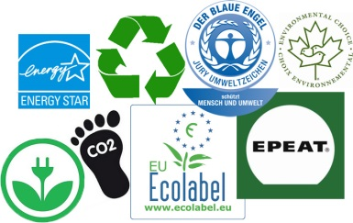 | Ecolabel is labeling that identifies overall, proven environmental preference of a product or service within a specific product/service category.
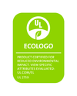  Ecologo | Ecologo is a logo that has gone through a product certification process for reduced environmental impact.  www.industries.ul.com/environment/certificationvalidation-marks/ecologo-product-certification
ENERGY STAR Qualifies  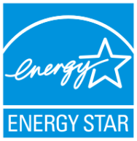 | ENERGY STAR Qualifies is an indication that the product uses less energy, saves money, and helps protect the environment.
EU | European Union
RoHS (Restriction of Hazardous Substances  ) | Directive 2002/95/EC  Through the EU and restricts the use of specific hazardous material found in electrical and electronic products  Effective July 1, 2006  eur-lex.europa.eu/LexUriServ/LexUriServ.do?uri=CELEX:32002L0095:EN:HTML
TCO (Total Cost of Ownership) | TCO is a financial estimate intended to help buyers and owners determine direct and indirect costs of a product or system.
WEEE (Waste Electrical and Electronic Equipment) | WEEE is a complex mixture of materials and components that because of their hazardous content, and if not properly managed, can cause major environmental and health problems.
EPEATS | Additional Information
Blue Angel | Blue Angel is a German certification process for products and services that have environmentally friendly aspects.  www.blauer-engel.de/en/home
Ecolabel | Ecolabel is labeling that identifies overall, proven environmental preference of a product or service within a specific product/service category.
Ecologo | Ecologo is a logo that has gone through a product certification process for reduced environmental impact.  www.industries.ul.com/environment/certificationvalidation-marks/ecologo-product-certification
ENERGY STAR Qualifies | ENERGY STAR Qualifies is an indication that the product uses less energy, saves money, and helps protect the environment.
EU | European Union
RoHS (Restriction of Hazardous Substances  ) | Directive 2002/95/EC  Through the EU and restricts the use of specific hazardous material found in electrical and electronic products  Effective July 1, 2006  eur-lex.europa.eu/LexUriServ/LexUriServ.do?uri=CELEX:32002L0095:EN:HTML
TCO (Total Cost of Ownership) | TCO is a financial estimate intended to help buyers and owners determine direct and indirect costs of a product or system.
WEEE (Waste Electrical and Electronic Equipment) | WEEE is a complex mixture of materials and components that because of their hazardous content, and if not properly managed, can cause major environmental and health problems.

